INFORMATION TECHNOLOGY INSTITUTE (ITI)
Ministry of Communications and Information Technology
FINAL PROJECT DOCUMENTATION
Enterprise Telecom Operations Management Platform
A ServiceNow-Based Employee Center, Complaint, Incident, Outage and Field Service Management Application

Prepared By:
Salma Nader
Mariam Mohammed
Amr Alaa
Hatem Elaraby
Mahmoud AbdelHameed
Habiba Mohammed

Track: ServiceNow Platform Administration & Development
Platform: ServiceNow Personal Developer Instance (PDI) | Application Scope: (x_1979775_enterp_0)
Graduation Project 2026

Table of Contents
Chapter 1: Introduction
Chapter 2: Literature Review / Background
Chapter 3: Requirements
Chapter 4: System Design
Chapter 5: Implementation
Chapter 6: Testing
Chapter 7: Results & Discussion
Chapter 8: Conclusion & Future Work
References & Appendices

Chapter 1: Introduction

1.1 Project Overview
The Enterprise Telecom Operations Management Platform is a scoped ServiceNow application, developed under the application scope (x_1979775_enterp_0) on a ServiceNow Personal Developer Instance (PDI), that digitizes and automates the core operational workflow of a telecom service provider. The platform was designed and implemented as part of the ITI graduation project track focused on the ServiceNow platform, and it demonstrates end-to-end ServiceNow administration and development skills, from data modeling and security design through automation, Service Portal delivery, SLA management, and reporting.
The application models the complete lifecycle of a telecom customer's operational journey: an employee-facing service records and manages customer profiles and service plans, customers raise complaints about network or billing issues, complaints are automatically escalated into ServiceNow Incidents, incidents and complaints are correlated with network outages, outages trigger field engineer dispatch and repair tasks, and resolved cases can generate customer compensation records. Every stage of this journey is tracked, timed against Service Level Agreements (SLAs), and visualized through dashboards and reports that give operations managers real-time visibility into complaint volumes, active outages, SLA breaches, and engineer workload.

1.2 Problem Statement
Telecom operators typically face a set of recurring operational challenges that directly affect customer satisfaction and internal efficiency:
- High volumes of customer complaints related to network outages, slow internet, dropped calls, billing disputes, and SIM issues, often managed through disconnected spreadsheets, phone calls, or email threads.
- Network outages that are not centrally tracked, making it difficult to correlate a spike in customer complaints with a specific infrastructure failure (tower down, fiber cut, power failure, network congestion).
- Slow resolution times are caused by manual assignment of complaints and repair tasks to the correct team or field engineer, with no automated routing or escalation.
- Poor tracking of resolution commitments — without a formal SLA mechanism, there is no objective way to measure whether critical issues were resolved within an acceptable time window.
- Lack of a single, unified view for operations managers to monitor open complaints, active outages, SLA compliance, and field engineer workload.
These problems translate into longer downtime for customers, inconsistent complaint handling, missing SLA targets, and reducing customer trust. The Enterprise Telecom Operations Management Platform was built specifically to address these pain points using native ServiceNow capabilities rather than custom, hard-to-maintain scripting.

1.3 Project Objectives
The project was designed to achieve the following objectives:
- Provide a structured way to record and manage telecom customer profiles and their associated service plans.
- Allow customer complaints to be logged, categorized, and routed to the correct resolution team automatically.
- Automatically create a ServiceNow Incident whenever a telecom complaint is raised, integrating the telecom process with standard ITSM incident management.
- Track network outages centrally, linking them to the complaints and incidents they caused.
- Automatically generate field engineer tasks for outage resolution and track engineer status from assignment through work completion.
- Enforce SLA timers on both complaints and outages, based on priority and severity, so resolution performance can be measured objectively.
- Trigger event-driven email notifications at every key milestone of the process (registration, complaint confirmation, incident creation, outage alert, engineer assignment, compensation approval).
- Deliver a role-based Service Portal experience so both employees and customers can interact with the platform without accessing the native ServiceNow UI.
- Provide operations managers with KPI dashboards and standalone reports to monitor complaint trends, outage status, SLA breaches, and engineer workload.
- Apply ACL-based security so that each role (customer, complaint agent, network engineer, field engineer, operations manager) can only see and act on the data relevant to their responsibilities.

1.4 Scope & Limitations

1.4.1 In Scope
- Employee scope: complaint agents, network engineers, field engineers, and operations managers work entirely within the ServiceNow platform (native UI and, where applicable, the Service Portal) to manage complaints, outages, engineer tasks, and compensation.
- Customer scope: Customer profile creation is handled as an internal employee-facing service rather than an open self-registration form — this is intentional and is explained further below — while complaint raising, complaint tracking, outage status visibility, and compensation requests are exposed to customers through the Telecom Customer Portal.
- Core ServiceNow capabilities used: scoped application development, custom tables extending the Task table, Service Catalog and Record Producers, Flow Designer automation, Business Rules, Client Scripts, UI Policies, Data Policies, Script Includes with GlideAjax, SLA Definitions, Notifications and Events, Service Portal widgets, Reports, and Performance Analytics-style Dashboards.

1.4.2 Key Design Decision — Employee Center instead of Open Customer Self-Registration

Unlike the original project brief, which specifies an open, unauthenticated "Customer Registration" Record Producer on the portal, this implementation registers customers through an Employee Center instead. In practice this means customer profile creation is performed by an authorized employee (e.g. a complaint agent or operations team member) through a Service Catalog item / employee-facing form, rather than by the customer themselves through an open public registration page. All other flows — raising a complaint, tracking complaint and outage status, and requesting compensation — remain customer-facing on the Telecom Customer Portal exactly as specified. This decision was taken to keep customers onboarding under employee control (data quality, identity verification, and duplicate prevention), and it is the only functional deviation from the original specification; every other module, table, phase, and rule was implemented as designed.

1.4.3 Out of Scope / Limitations
- The project runs on a single ServiceNow PDI and is not integrated with a real telecom network monitoring system, billing engine, or external CRM — outage and billing data are simulated manually for demonstration purposes.
- Advanced Service Portal development (custom Angular widgets, complex client-side scripting) was intentionally avoided in favor of native, low-code portal components (Record Producers, Data Table widget, Simple List widget), in line with the project's beginner-friendly build rules.
- Payment processing for compensation (bill credits, refunds) is modeled as an approval workflow only; no real financial transaction or payment gateway integration is included.
- Mobile-native applications are out of scope — access is limited to the ServiceNow native UI (for employees) and the responsive Service Portal (for customers and employees).

Chapter 2: Literature Review / Background

2.1 Overview of the ServiceNow Platform
ServiceNow is a cloud-based Platform-as-a-Service (PaaS) originally built around IT Service Management (ITSM) that has since expanded into a general-purpose workflow automation platform used across IT, customer service, HR, security, and field operations. Its core architectural building blocks — tables, forms, business rules, client scripts, ACLs, Flow Designer, and the Service Portal — allow developers to build fully custom applications, called scoped applications, that sit alongside ServiceNow's out-of-the-box products without interfering with them.
A scoped application (identified by an application scope such as x_1979775_enterp_0 in this project) is ServiceNow's mechanism for name spacing custom tables, fields, business logic, roles, and UI so that a project remains self-contained, upgrade-safe, and cleanly separated from other applications on the same instance. This project was built entirely inside its own scope, which is why every custom table, field, script include, and role is prefixed with x_1979775_enterp_0.

2.2 ITSM, CSM, and Field Service Concepts Used in This Project

2.2.1 IT Service Management (ITSM)
ITSM is the set of ServiceNow capabilities used to manage IT (and, by extension, operational) incidents, problems, and changes. This project uses the standard Incident table as the backbone of its escalation model: every telecom complaint that represents a service-affecting issue automatically generates a linked Incident record, which allows the ITSM Support Team to apply standard incident-handling practices (prioritization, assignment, resolution tracking) on top of the telecom-specific complaint data.

2.2.2 Customer Service Management (CSM) Concepts
Although this project does not use ServiceNow's dedicated CSM product, it borrows CSM's core philosophy: giving the customer a self-service channel (the Telecom Customer Portal) to raise issues, track their status, and request compensation, while giving internal teams (complaint agents, network engineers) a structured back-office process to resolve those issues. The Task table pattern — extended by the Complaint, Outage, and Engineer Task tables — mirrors the same case-management approach that CSM uses for customer cases.

2.2.3 Field Service Management (FSM) Concepts
Field Service Management concerns the dispatch and tracking of technicians who resolve issues on-site. This project implements a simplified version of that pattern through the Field Engineer Task table: when a network outage is created, an engineer task is automatically generated, an engineer status is tracked through a defined lifecycle (Assigned, Traveling, On Site, Work Completed), and completing the task automatically closes the related outage — the same assign-and-close pattern used in full FSM implementations.

2.3 Why ServiceNow Is a Good Fit for Telecom Operations
Telecom operators need to correlate four things that are traditionally tracked in separate systems: customer records, customer-reported issues, network infrastructure events, and field repair work. ServiceNow is well suited to this problem for several reasons that directly shaped the design of this project:
- Task-based data model: ServiceNow's Task table already provides number generation, state, priority, assignment, and activity/work-notes tracking out of the box. Extending Task for the Complaint, Outage, and Engineer Task tables meant the project inherited a proven, consistent lifecycle model instead of re-inventing it, exactly as instructed by the project's "do not duplicate Task fields" rule.
- Native automation (Flow Designer) removes the need for heavy custom scripting to connect the Complaint → Incident → Outage → Engineer Task chain, keeping the automation maintainable and readable for future developers.
- Built-in SLA engine allows resolution-time commitments to be defined declaratively (start/pause/stop conditions per priority or severity) instead of being calculated manually in scripts.
- ACL-based security model enables fine-grained, role-based access control so that a customer can only see their own complaints, while a complaint agent sees all complaints assigned to their team, without writing custom authorization logic.
- Service Portal + Record Producers give non-technical customers and employees a simple, guided way to submit structured data (new complaints, compensation requests) that flows directly into the same tables used internally, avoiding duplicate systems or manual re-entry.
- Reporting, Dashboards, and Performance Analytics-style widgets turn the same operational data used for day-to-day work into real-time KPIs for operations managers, with no separate business-intelligence tool required.
Taken together, these capabilities let a single ServiceNow scoped application cover the entire telecom operations lifecycle — from customer record to field repair to compensation — with a level of consistency, traceability, and automation that would otherwise require integrating several disconnected systems.

Chapter 3: Requirements

3.1 Functional Requirements

3.1.1 Employee / Customer Onboarding
- FR-1: An authorised employee shall be able to register a new telecom customer profile (Full Name, Mobile Number, Email, Address, City, State, ZIP Code, Service Plan, Customer Type, Customer Status) through an employee-facing service.
- FR-2: The system shall automatically create a corresponding ServiceNow user account (sys_user) and assign the customer role whenever a new customer profile is created.
- FR-3: The system shall prevent duplicating customer records by validating the mobile number before insert.

3.1.2 Complaint Management
- FR-4: Customers shall be able to raise a complaint from the portal by selecting a Complaint Type (No Network, Slow Internet, Call Drop, Billing Issue, SIM Issue), Impact Level, Area Impacted, and a Description.
- FR-5: The system shall automatically assign every new complaint to the Complaint Resolution Team.
- FR-6: The system shall automatically calculate complaint Priority from the selected Impact Level (Critical → 1, High → 2, Medium → 3, Low → 4).
- FR-7: The system shall make the Related Outage field mandatory whenever the Complaint Type is set to "No Network".
- FR-8: Customers shall be able to view the status of their own complaints from the portal (My Complaints).

3.1.3 Incident Integration
- FR-9: The system shall automatically create a linked Incident record whenever a new complaint is inserted, copying the relevant complaint details across.
- FR-10: The system shall automatically assign newly created incidents to the ITSM Support Team and notify them by email.

3.1.4 Network Outage Management
- FR-11: Network engineers shall be able to log a network outage (Outage Type, Impacted Area, Impacted Customers, Severity, Root Cause) and link it to the related complaint(s) and incident.
- FR-12: The system shall automatically assign new outages to the Network Operations Team and automatically generate a Field Engineer Task.
- FR-13: Customers shall be able to view the status of active outages from the portal (Outage Status page).

3.1.5 Field Engineer Dispatch
- FR-14: Field engineers shall be assigned to an engineer task and shall update their status through a defined lifecycle: Assigned, Traveling, On Site, Work Completed.
- FR-15: The Engineer field shall be mandatory on the Field Engineer Task form.
- FR-16: The system shall automatically close the related network outage once the engineer status is set to "Work Completed".

3.1.6 Compensation
- FR-17: Customers shall be able to request compensation (Bill Credit, Refund, Free Data) linked to a resolved complaint, through the portal.
- FR-18: The Operations Manager shall be able to approve or reject a compensation request; approval shall trigger a customer notification.

3.1.7 SLA, Notifications & Events
- FR-19: The system shall enforce SLA timers on complaints (based on Priority) and outages (based on Severity), including start, pause, and stop conditions.
- FR-20: The system shall raise system events (customer.created, complaint.created, incident.created, outage.created, engineer.assigned, compensation.approved) and trigger the corresponding email notification for each event.

3.1.8 Reporting & Dashboard
- FR-21: The system should provide a Telecom Operations Dashboard showing Open Complaints, Active Outages, SLA Breaches, Engineer Workload, and Complaint Trend widgets.
- FR-22: The system shall provide standalone reports for complaints by type, open outages, engineer task status, SLA breaches, and complaint trends.

3.2 Non-Functional Requirements

3.2.1 Security
- NFR-1: Access Control Lists (ACLs) shall restrict each table so that customers can only see their own records, complaint data is visible only to the Complaint Resolution Team, outage data only to the Network Operations Team, engineer task data only to the Field Engineering Team, and compensation data only to the Operations Manager.
- NFR-2: All custom roles shall be scoped to the application (x_1979775_enterp_0) to avoid unintended access outside the application.
- NFR-3: Mandatory fields (e.g. Mobile Number, Description) shall be enforced through Data Policies so that both the platform UI and the Service Portal apply the same validation.

3.2.2 Performance
- NFR-4: Business Rules and Flow Designer flows shall be kept simple (a maximum of 3–5 actions per flow) to minimize execution overhead and keep automation maintainable.
- NFR-5: Dashboard KPI widgets shall reflect near real-time data using standard ServiceNow reporting refresh behavior.

3.2.3 Usability
- NFR-6: Forms shall be organized into clear, purpose-driven sections (e.g. Customer Information, Complaint Details, Assignment Information, Resolution Information, Activity) to keep data entry simple for agents.
- NFR-7: Customer-facing interactions shall use simple, guided Service Portal components — Record Producers, the Data Table widget, and the Simple List widget — rather than advanced custom widgets, to keep the customer experience straightforward.
- NFR-8: Every module shall be independently testable, and the full demo flow (customer creation through dashboard update) shall be verifiable end-to-end before final delivery.

Chapter 4: System Design

4.1 Application Scope
The entire application was built as a single ServiceNow scoped application to keep all custom tables, fields, roles, business logic, and Service Portal artifacts self-contained and cleanly separated from other applications on the PDI.
Property | Value
Application Name | Telecom Operations Management
Application Scope | x_1979775_enterp_0
Application Type | Scoped Application
Platform | ServiceNow Personal Developer Instance (PDI)
Application Menu | Telecom Operations

4.2 Data Model
The data model consists of six custom tables. Three of them — Telecom Complaint, Network Outage, and Field Engineer Task — extend the out-of-the-box Task table so that number generation, state, priority, assignment, and activity tracking are inherited rather than rebuilt. The remaining three — Customer Profile, Service Plan, and Compensation — are standalone custom tables.

4.2.1 Task Table Fields Reused (Not Duplicated)
Wherever a table extends Task, the project deliberately reuses the following inherited fields instead of creating duplicates:
Task Field | Purpose in This Project
Number | Auto-generated record number (renamed per table, e.g. Complaint Number, Outage Number)
State | Lifecycle status of the complaint / outage / engineer task
Priority | Urgency, driving SLA timers
Assigned To | The individual agent / engineer handling the record
Assignment Group | The team responsible for the record
Short Description / Description | Summary and detailed description of the issue
Comments | Customer-visible updates
Work Notes | Internal-only notes
Due Date | Target resolution date

4.2.2 Table 1 — Customer Profile (x_1979775_enterp_0.customer_profile)
Extends: None (standalone custom table). Purpose: stores telecom customer master data.
Field Label | Type | Choices / Reference
Customer Number | Auto Number | —
Full Name | String | —
Mobile Number | Phone Number | —
Email Address | Email | —
Address | String | —
City | String | —
State | Choice | NY, CA, TX, FL, IL
ZIP Code | String | —
Service Plan | Reference | x_1979775_enterp_0.service_plan
Customer Type | Choice | Prepaid, Postpaid, Enterprise
Customer Status | Choice | Active, Suspended, Disconnected
User Account | Reference | sys_user

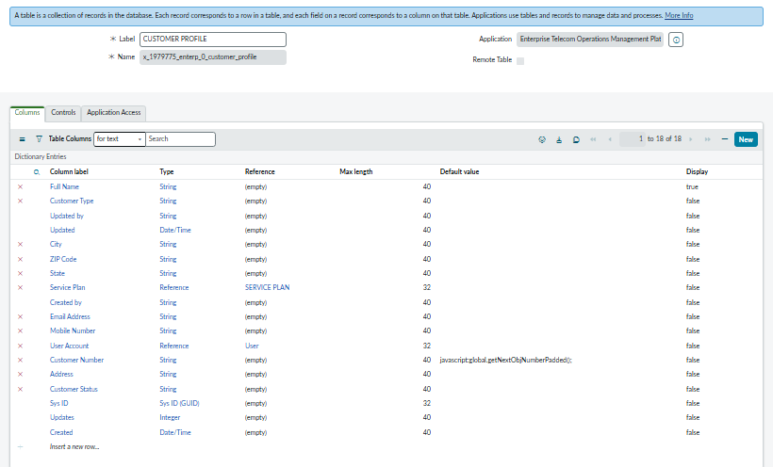
Customer Profile table — dictionary / field list view

4.2.3 Table 2 — Service Plan (x_1979775_enterp_0.service_plan)
Extends: None (standalone custom table). Purpose: stores the telecom service plans customers can subscribe to.
Field Label | Type | Choices / Reference
Plan Number | Auto Number | —
Plan Name | String | —
Plan Type | Choice | Mobile, Broadband, Fiber
Monthly Cost | Currency | —
Data Limit | Integer | —
Call Limit | Integer | —
SMS Limit | Integer | —
Plan Status | Choice | Active, Retired

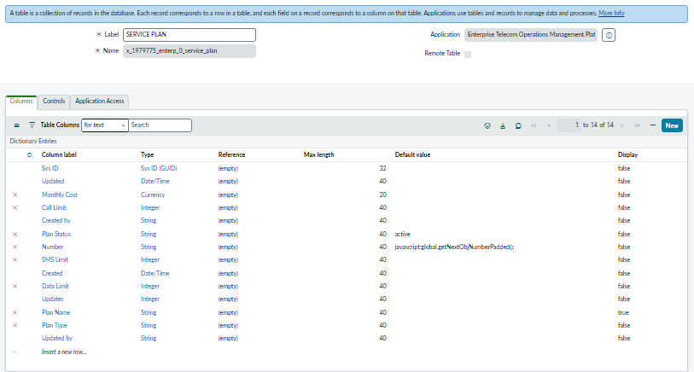
Service Plan table — dictionary / field list view

4.2.4 Table 3 — Telecom Complaint (x_1979775_enterp_0. customer_complaint)
Extends: Task table (Number renamed to Complaint Number). Purpose: stores every customer complaint and drives the escalation to Incident.

Field Label | Type | Choices / Reference
Customer | Reference | x_1979775_enterp_0.customer_profile
Complaint Type | Choice | No Network, Slow Internet, Call Drop, Billing Issue, SIM Issue
Complaint Channel | Choice | Portal, Call Center, Store
Impact Level | Choice | Critical, High, Medium, Low
Area Impacted | String | —
Resolution Status | Choice | Open, In Progress, Pending Customer, Resolved, Closed
Related Outage | Reference | x_1979775_enterp_0. network_outage
Related Incident | Reference | incident
Recommended State choices: New, Open, Work in Progress, Pending, Resolved, Closed. Recommended Priority choices: 1 – Critical, 2 – High, 3 – Medium, 4 – Low.

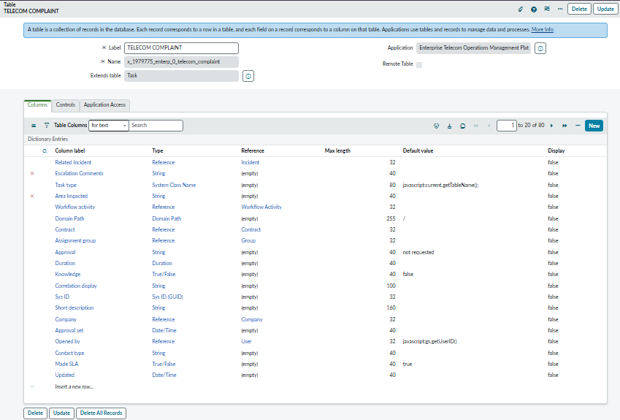
Telecom Complaint table — dictionary / field list view

4.2.5 Table 4 — Network Outage (x_1979775_enterp_0.network_outage)
Extends: Task table (Number renamed to Outage Number). Purpose: tracks network outages and their resolution.
Field Label | Type | Choices / Reference
Outage Type | Choice | Tower Down, Fiber Cut, Power Failure, Network Congestion
Impacted Area | String | —
Impacted Customers | Integer | —
Severity | Choice | Critical, High, Medium, Low
Root Cause | HTML | —
Outage Status | Choice | Open, Investigating, Engineer Assigned, Resolved, Closed
Related Incident | Reference | incident

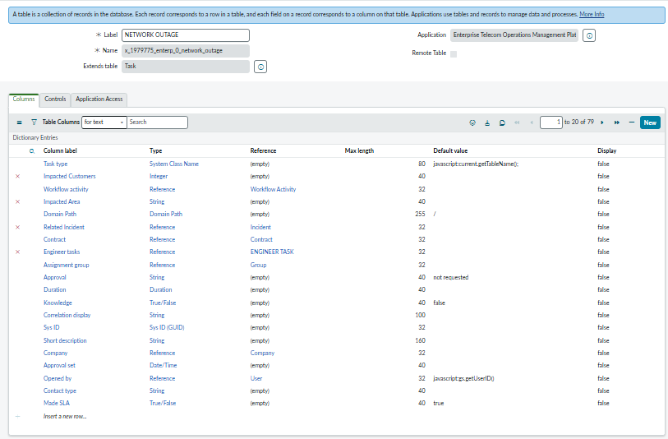
Network Outage table — dictionary / field list view

4.2.6 Table 5 — Field Engineer Task (x_1979775_enterp_0.field_engineer_task)
Extends: Task table (Number renamed to Engineer Task Number). Purpose: stores the field engineer's repair work against an outage.
Field Label | Type | Choices / Reference
Related Outage | Reference | x_1979775_enterp_0.network_outage
Engineer | Reference | sys_user
Engineer Status | Choice | Assigned, Traveling, On Site, Work Completed
Estimated Arrival | Date/Time | —
Resolution Notes | HTML | —

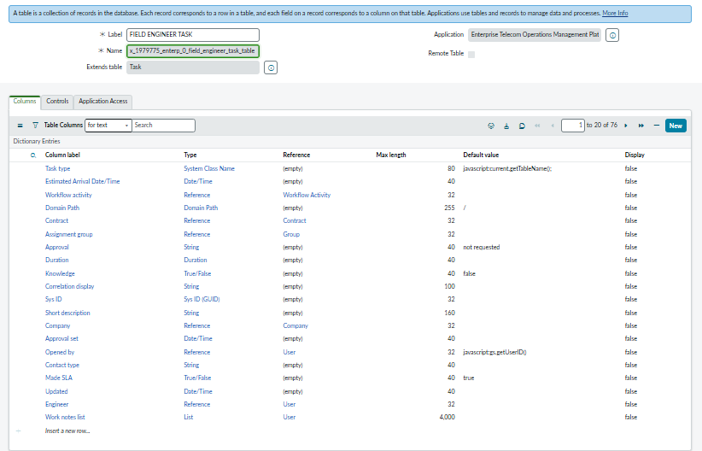
Field Engineer Task table — dictionary / field list view

4.2.7 Table 6 — Compensation (x_1979775_enterp_0. compensation)
Extends: None (standalone custom table). Purpose: stores customer compensation requests and their approval status.
Field Label | Type | Choices / Reference
Compensation Number | Auto Number | —
Customer | Reference | x_1979775_enterp_0. customer_profile
Related Complaint | Reference | x_1979775_enterp_0. complaint
Compensation Type | Choice | Bill Credit, Refund, Free Data
Compensation Amount | Currency | —
Approval Status | Choice | Pending, Approved, Rejected

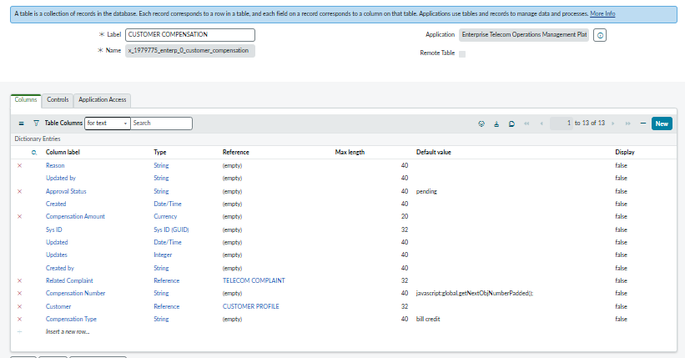
Compensation table — dictionary / field list view

4.3 Table Relationships
The diagram below (to be inserted as a schema map or hand-drawn diagram) illustrates how the six tables relate to one another. The primary chain flows from Customer through Complaint, Incident, Network Outage, and Field Engineer Task; Compensation links back to both Customer and Complaint independently.
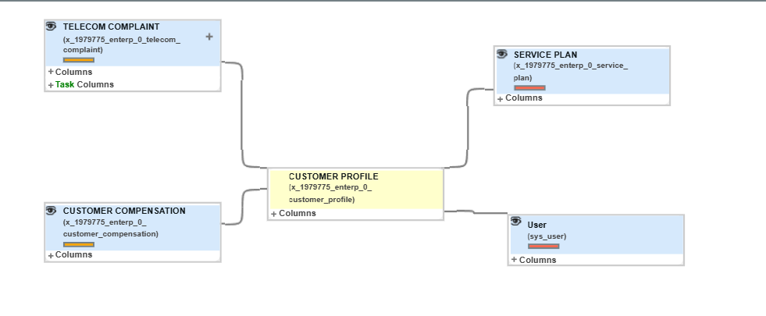
Table Relationships Diagram — Customer → Complaint → Incident → Network Outage → Field Engineer Task, with Compensation linked to Customer and Complaint

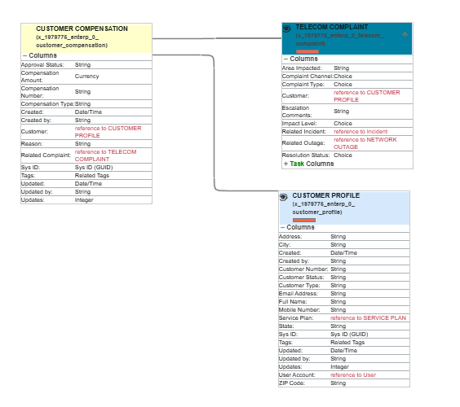
Primary relationship chain: Customer → Complaint → Incident → Network Outage → Field Engineer Task.
Secondary relationship: Customer → Compensation, and Complaint → Compensation.

4.4 Roles & Groups

4.4.1 Role Structure
Role Name | Responsibility
x_1979775_enterp_0. customer | Portal access for customers
x_1979775_enterp_0. complaint_agent | Handle and resolve complaints
x_1979775_enterp_0. network_engineer | Manage network outages
x_1979775_enterp_0. field_engineer | Resolve field engineer tasks
x_1979775_enterp_0. operations_manager | Approvals & dashboard visibility

4.4.2 Group Structure & Role Mapping
Group Name | Purpose | Role Assigned
Telecom Customers | Portal users | x_1979775_enterp_0. customer
Complaint Resolution Team | Complaint handling | x_1979775_enterp_0. complaint_agent
Network Operations Team | Outage handling | x_1979775_enterp_0. network_engineer
Field Engineering Team | Engineer field work | x_1979775_enterp_0. field_engineer
Telecom Operations Team | Operations monitoring | x_1979775_enterp_0. operations_manager
ITSM Support Team | Incident handling | itil

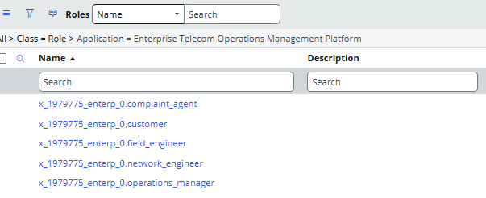
Roles List

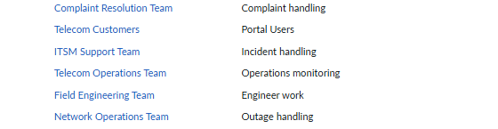
Groups list with role membership, as configured in the platform

Chapter 5: Implementation
Implementation followed the mandatory build order defined for the project, so that every dependency (tables before forms, forms before scripts, scripts before automation) was respected. This section summarizes each of the eleven phases and lists the corresponding screenshots to be inserted as evidence of the completed work.

5.1 Phase 1 — Application Setup
- Created the scoped application "Telecom Operations Management" with x_1979775_enterp_0.
- Created the five custom roles listed in the Role Structure table (Section 4.4.1). The itil and admin roles are built-in ServiceNow roles that were reused, not created.
- Created all six groups listed in the Group Structure table and assigned the corresponding role to each group (one of the six — ITSM Support Team — uses the built-in itil role rather than a custom one).
- Created the application menu "Telecom Operations" to organize all modules under a single navigation entry.
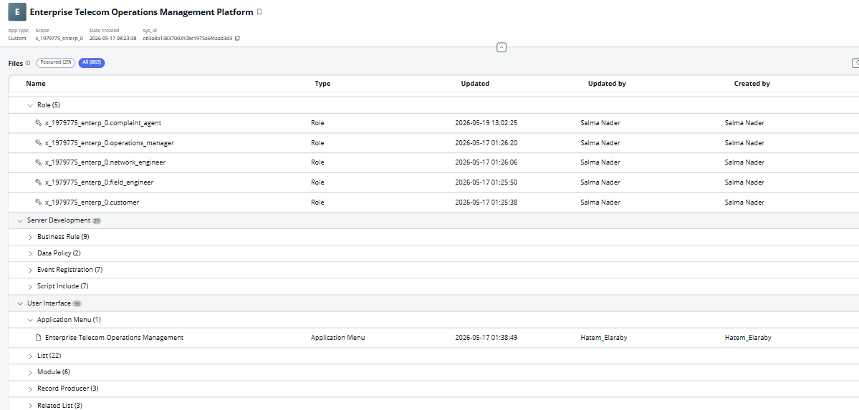Scoped Application record, Roles list, Groups list, and Application Menu

5.2 Phase 2 — Data Model Setup
All six custom tables described in Section 4.2 were created, with the three Task-extended tables (Complaint, Outage, Engineer Task) inheriting Number, State, Priority, Assigned To, Assignment Group, Comments, and Work Notes rather than duplicating them.
Table list showing all six x_telcom_* tables with their parent table (Task or none)

5.3 Phase 3 — Forms & UI Configuration
Each form was organized into logical sections (tabs) to keep data entry clear for each user role.
Form | Sections (Tabs)
Complaint Form | Customer Information, Complaint Details, Assignment Information, Resolution Information, Activity
Outage Form | Outage Information, Area Information, Assignment Information, Resolution Information, Activity
Engineer Task Form | Engineer Information, Outage Information, Work Information, Activity

Related lists were configured so that each parent record shows its dependent records directly on the form:
Parent Table | Related List Added
Customer | Complaints, Compensation
Complaint | Outages
Outage | Engineer Tasks

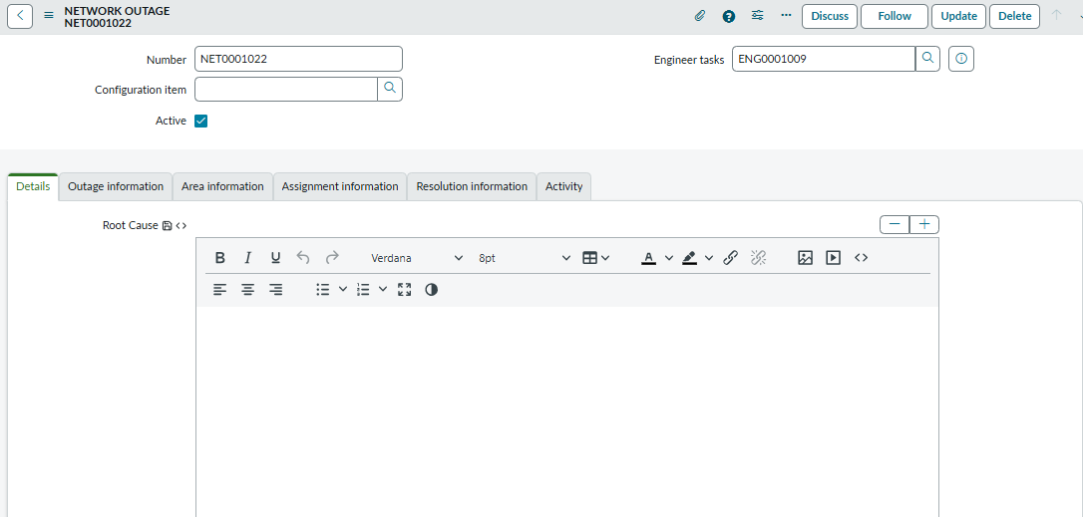

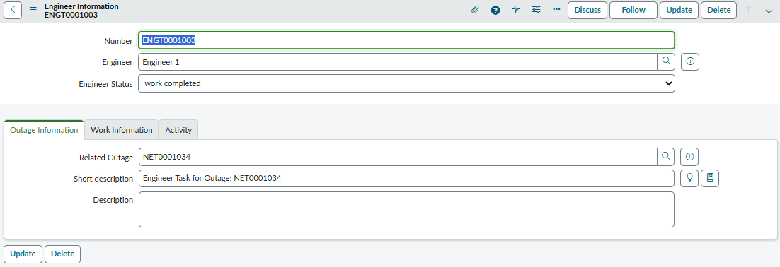

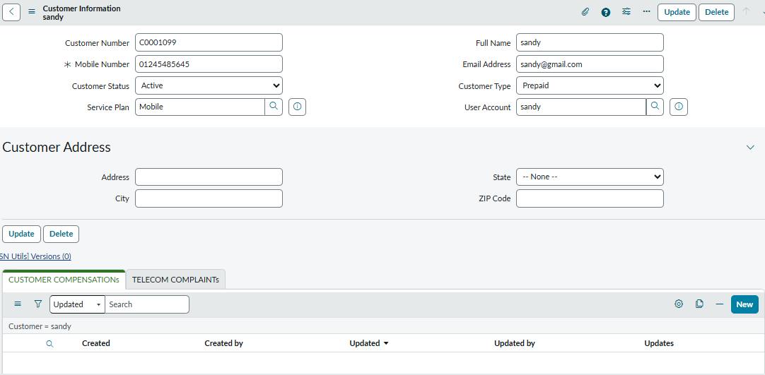

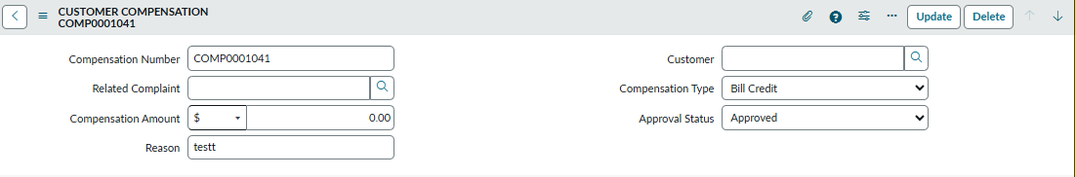

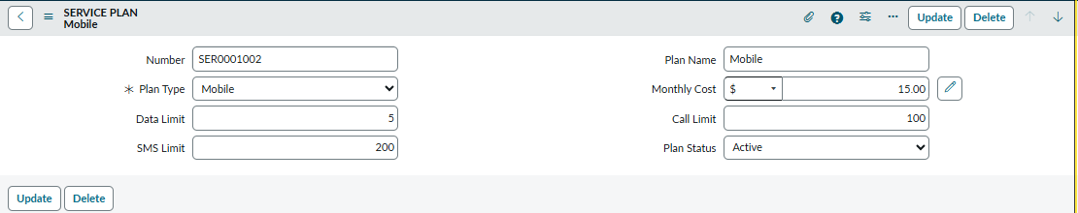

5.4 Phase 4 — Security (ACL) Configuration
ACL | Table | Access Rule
ACL 1 | Customer Table | Customers can see only their own record
ACL 2 | Complaint Table | Visible only to the Complaint Resolution Team
ACL 3 | Outage Table | Visible only to the Network Operations Team
ACL 4 | Engineer Task Table | Visible only to the Field Engineering Team
ACL 5 | Compensation Table | Visible only to the Operations Manager

5.5 Phase 5 — Client-Side Scripting

Client Script 1 — Mobile Number Validation
Type: onSubmit | Table: Customer Profile | Field: Mobile Number. Logic: if the mobile number is less than 10 digits, an error is shown and the submission is stopped and check if this mobile number exists before using Glide Ajax.
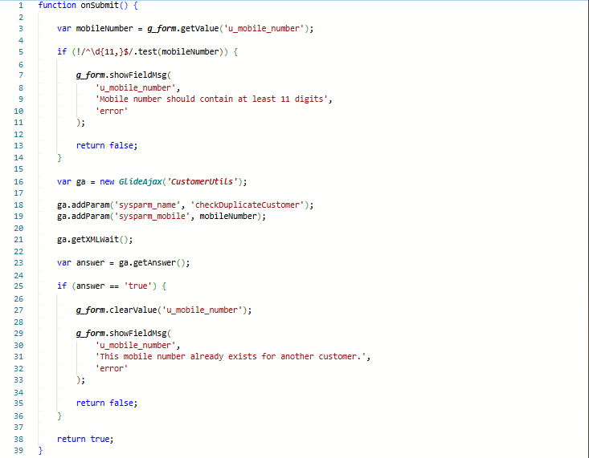

Client Script 2 — Auto Priority
Type: onChange | Table: Complaint | Fields: Impact Level, Priority. Logic mapping: Critical → 1, High → 2, Medium → 3, Low → 4.
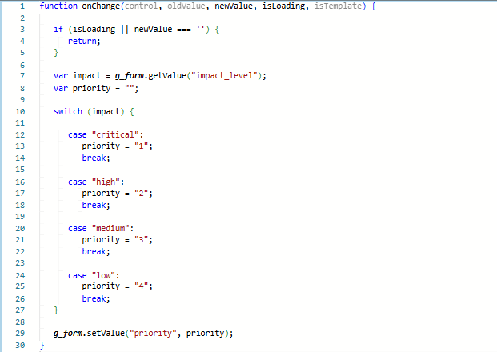

Client Script 3 — Engineer Validation
Type: onSubmit | Table: Engineer Task. Logic: the Engineer field cannot be left empty.
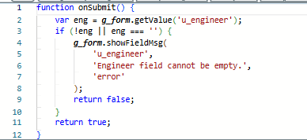

5.6 Phase 6 — Server-Side Scripting

5.6.1 UI Policies & Data Policies
Name | Table | Condition | Action
UI Policy 1 — Critical Complaint | Complaint | Impact Level = Critical | Show + require Escalation Comments
UI Policy 2 — Outage Required | Complaint | Complaint Type = No Network | Make Related Outage mandatory
Data Policy 1 — Mobile Mandatory | Customer | — | Mobile Number mandatory = True
Data Policy 2 — Description Required | Complaint | — | Description mandatory = True

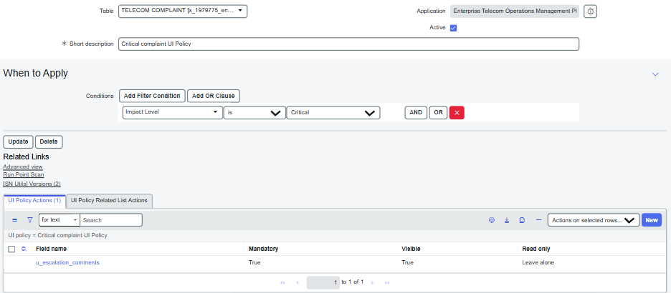
Ui policy 1— critical complaint
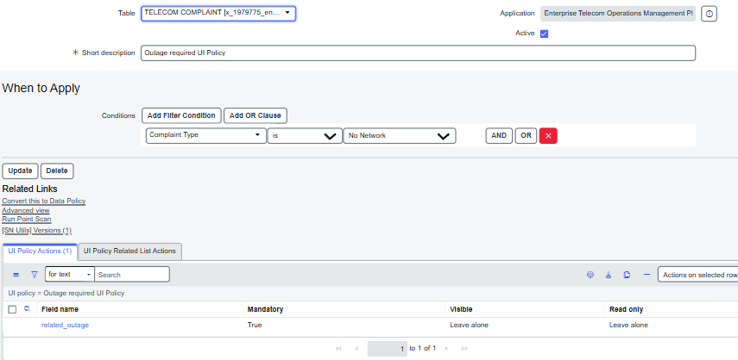
UI policy 2— Outage required

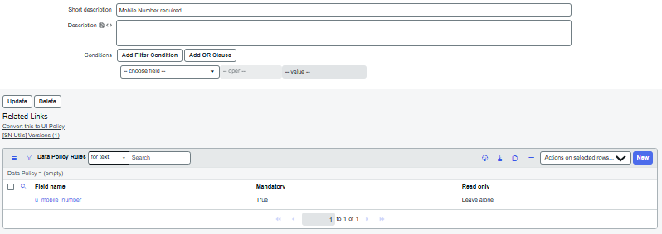
Data Policy 1 — Mobile Number required
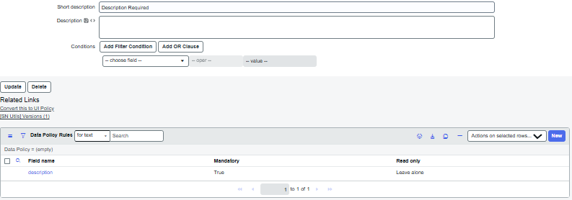Data Policy 2 — Description Required

5.6.2 Business Rules
Business Rule | Table | When | Logic
BR 1 — Create Portal User (Async) | Customer | After Insert | Async: create sys_user, copy name/email/mobile, assign customer role, link back to Customer record
BR 2 — Prevent Duplicate Mobile | Customer | Before Insert | Check for a duplicate mobile number and block the insert if found
BR 3 — Close Outage | Engineer Task | After Update | If Engineer Task Status = Work Completed, find and close the related outage

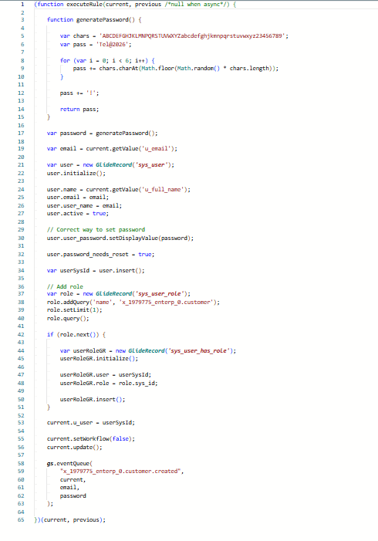
BR 1 —Create Portal User
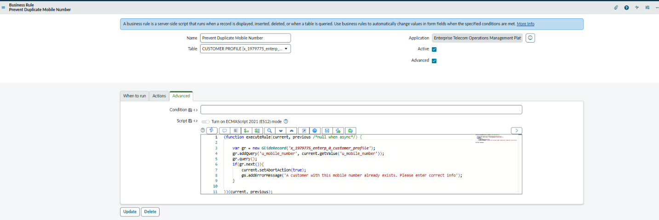
BR 2 — Prevent Duplicate Mobile Number
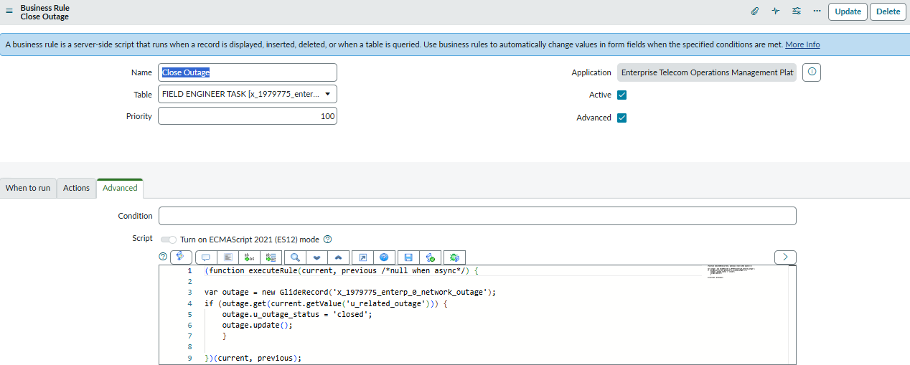
BR 3 —Close Outage

5.6.3 Script Includes & Glide Ajax
Script Include | Purpose | Key Functions
CustomerUtils | Customer validation | Validate customer, check duplicate mobile number
ComplaintUtils | Complaint processing | Set priority, assignment logic
EngineerUtils | Engineer handling | Create engineer task, find engineer
GlideAjax Call | Purpose | Input / Output
Customer Lookup | Fetch customer details | In: Mobile Number | Out: Name, Email, Plan
Area Validation | Validate impacted area | Standard input/output validation

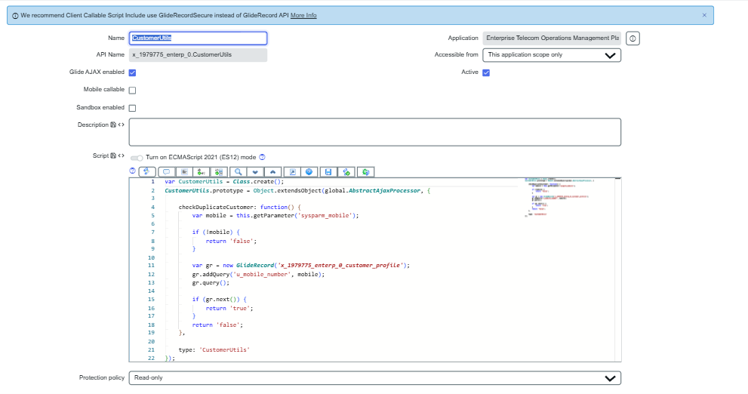
Script Include 1 —CustomerUtils

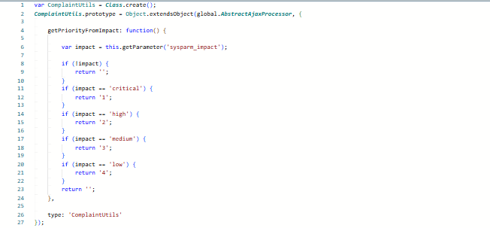Script Include 2 —Complaint Utils
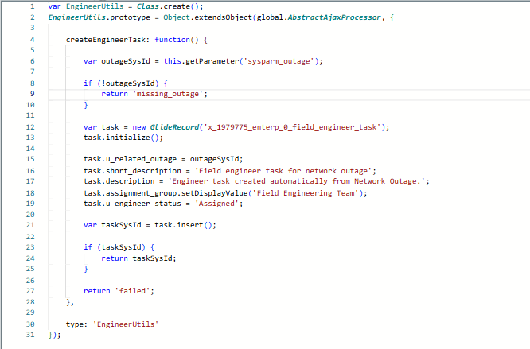
Script Include 3 —Engineer Utils
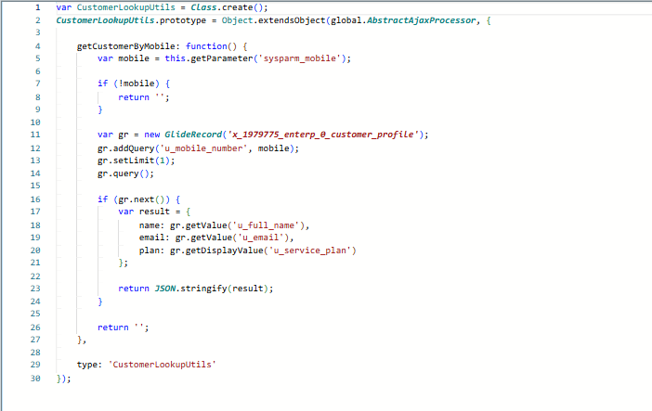
Script Include 4—Customer Lookup Utils

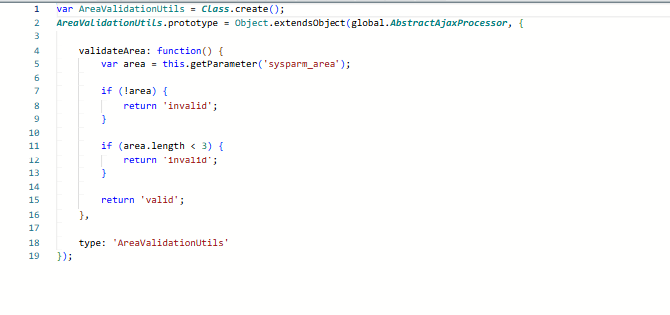
Script Include 5—Area Validation Utils

5.7 Phase 7 — Automation (Flow Designer)
Flow | Trigger | Actions
Flow 1 — Complaint Flow | Complaint created | Set priority, assign Complaint Resolution Team, create Incident, notify customer
Flow 2 — Outage Flow | Outage created | Assign Network Operations Team, create Engineer Task, send outage notification
Flow 3 — Compensation Flow | Compensation created | Send for approval, notify customer

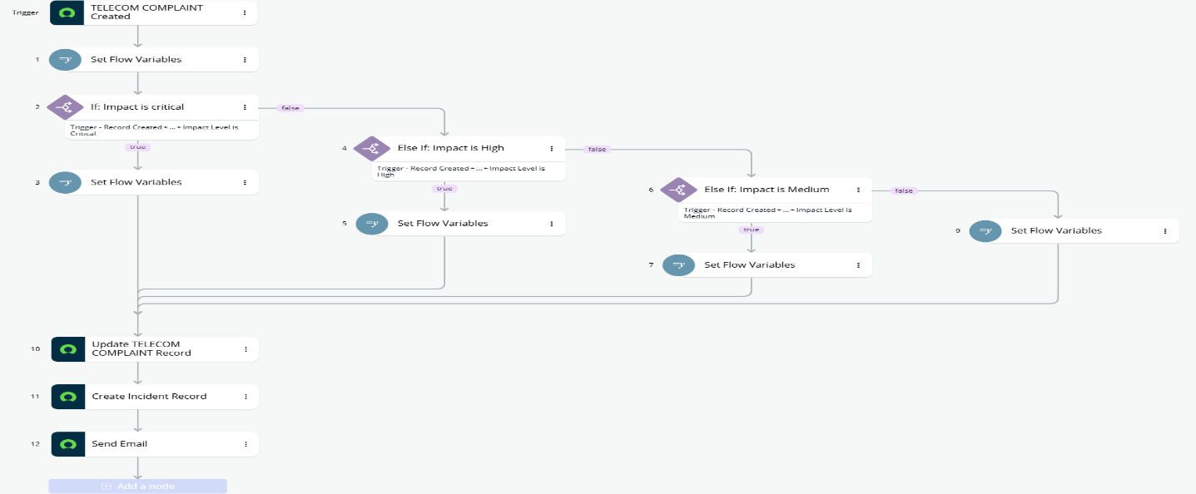
Flow 1 — Complaint Flow

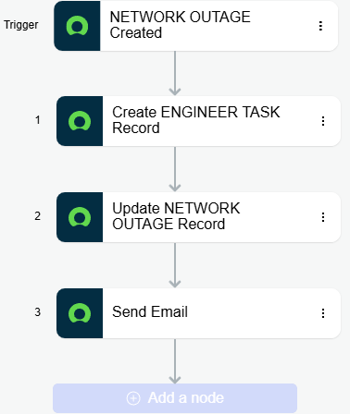
Flow 2 — Outage Flow

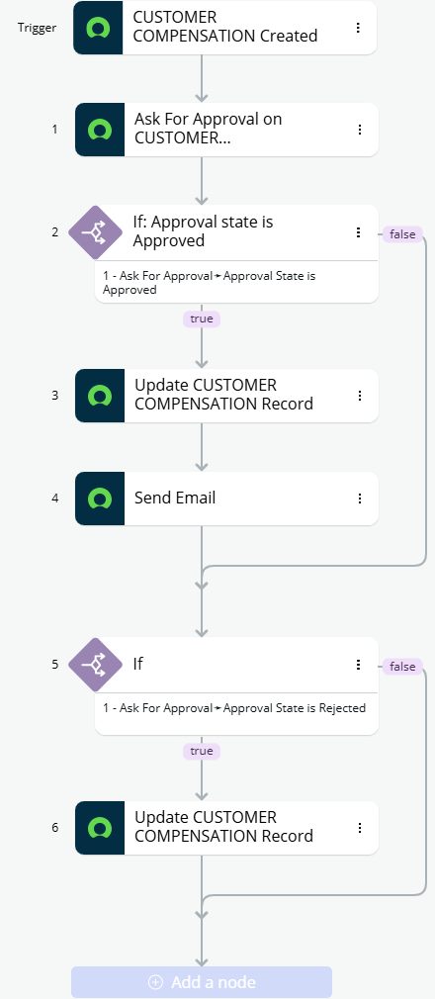
Flow 3 — Compensation Flow

5.8 Phase 8 — SLA, Events & Notifications

Complaint SLA
Table: Complaint | Start: State = Open | Pause: State = Pending | Stop: State = Resolved OR Closed.
Priority | SLA Time
Critical | 1 Hour
High | 4 Hours
Medium | 8 Hours
Low | 24 Hours

Outage SLA
Table: Outage | Start: State = Open | Stop: State = Resolved.
Severity | SLA Time
Critical | 30 Minutes
High | 2 Hours
Medium | 4 Hours
Low | 8 Hours

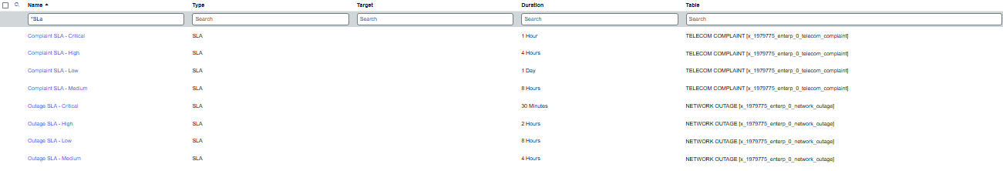SLA Definition

Events Registry
Event Name | Purpose
customer.created | Customer registration
complaint.created | Complaint created
incident.created | Incident created
outage.created | Outage created
engineer.assigned | Engineer assigned
compensation.approved | Compensation approved
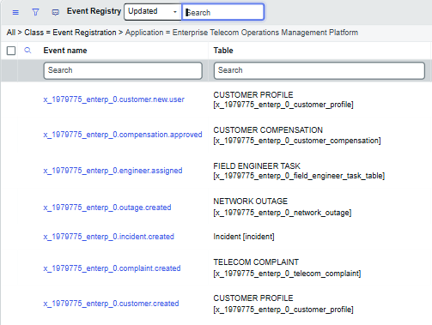Events list

Email Notifications
Notification | Trigger Event
Welcome Notification | customer.created
Complaint Confirmation | complaint.created
Incident Created | incident.created
Outage Alert | outage.created
Engineer Assigned | engineer.assigned
Compensation Approved | compensation.approved

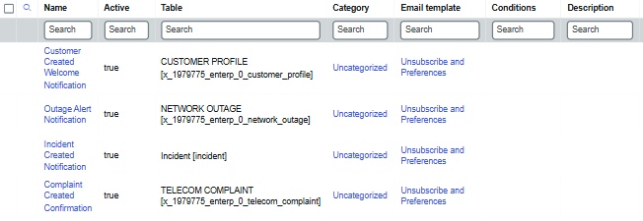Notifications list

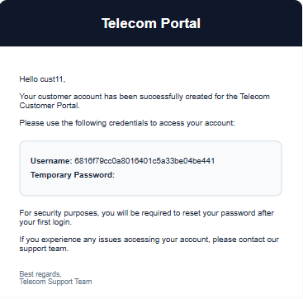Email Preview
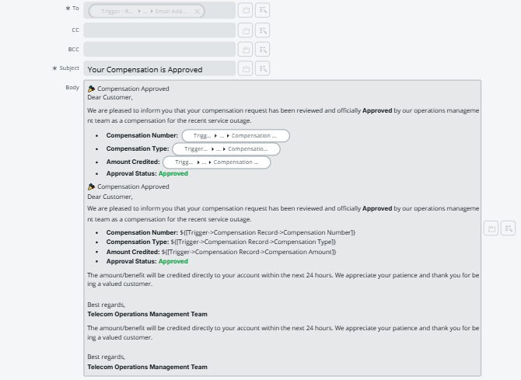Compensation Email

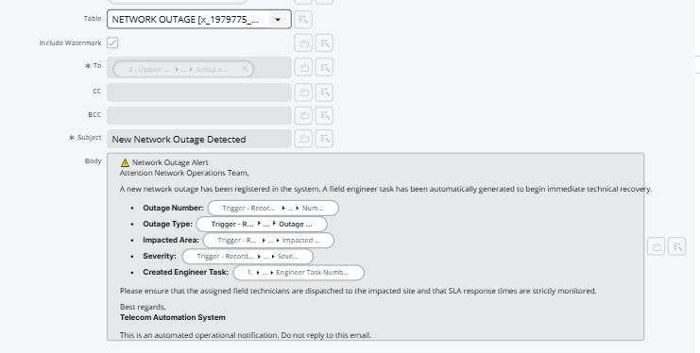Outage Email

5.9 Phase 9 —Telecom Portal
Portal Name: Telecom Customer Portal. In keeping with the project's beginner-friendly build rules, only Record Producers, the Data Table widget, and the Simple List widget were used — no advanced Angular widgets or complex client-side scripting.
Page | Purpose | Component / Widget
1. Home Page | Landing page | Welcome Widget, Quick Links Widget, My Complaints Widget, Active Outages Widget
2. Employee Center — Customer Registration | Register a customer (employee-facing, see Section 1.4.2) | Record Producer — Full Name, Mobile Number, Email, Address, Service Plan
3. Raise Complaint | Create a complaint | Record Producer — Complaint Type, Area Impacted, Impact Level, Description
4. My Complaints | View complaints | Data Table Widget — Number, State, Priority, Assigned To, Created
5. Outage Status | View outages | Simple List Widget — Number, Area, Severity, State
6. Compensation Request | Request compensation | Record Producer — Complaint, Compensation Type, Reason
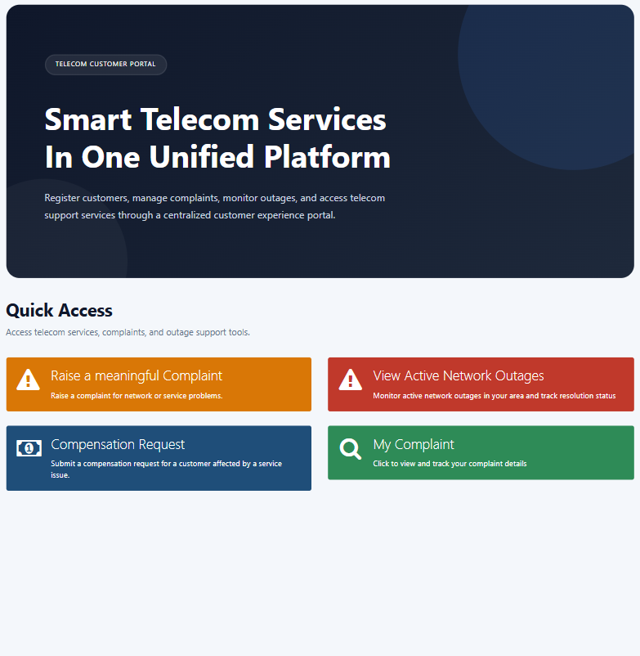
Telecom Portal — Home Page

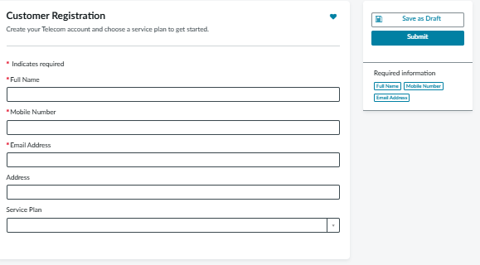
Employee Center Record Producer— Customer Registration

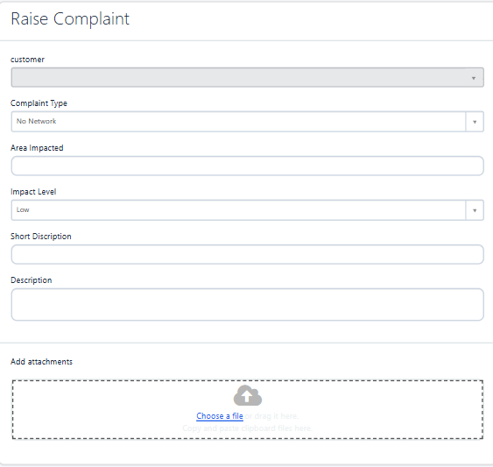
Record Producer — Raise Complaint

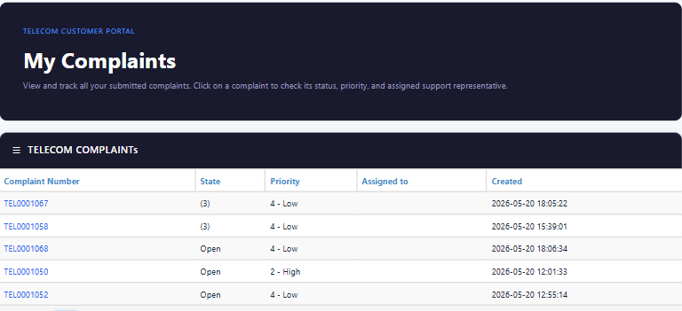
My Complaints List

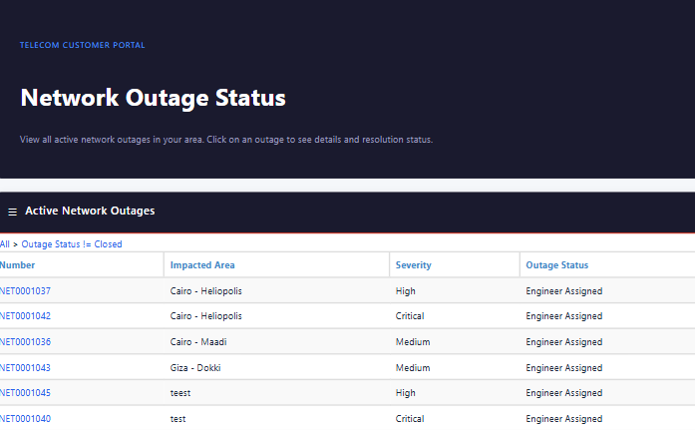
Outage Status List

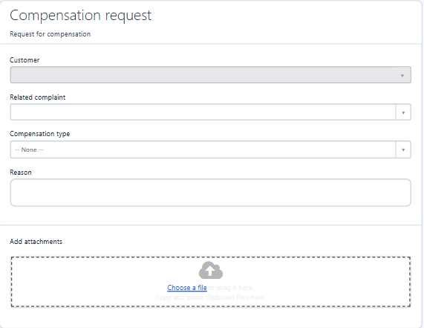
Record Producer — Compensation Request

5.10 Phase 10 — Reports & Dashboard
Dashboard: "Telecom Operations Dashboard", used by the Operations Manager (KPI monitoring), Complaint Agents (complaint tracking), and Network Engineers (outage tracking).
Widget | Type | Table / Group By | Purpose
Open Complaints | KPI | Complaint | State ≠ Closed | Track active complaints
Active Outages | KPI | Outage | State ≠ Resolved | Track active outages
SLA Breaches | Bar Chart | Task SLA | Track SLA violations
Engineer Workload | Pie Chart | Engineer Task | Assigned To | Track engineer workload
Complaint Trend | Line Chart | Complaint | Created Date | Track complaint trends

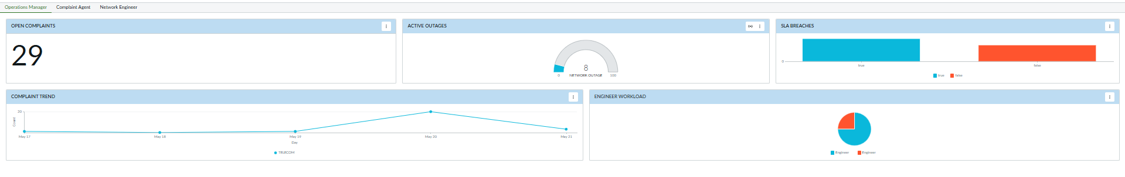
Dashboard — Operations Manager
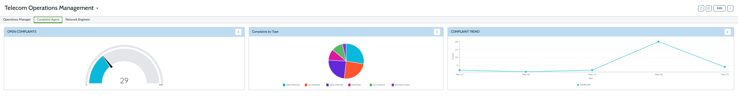
Dashboard — Complaints Agents

Standalone reports:
Report | Type | Group By
Complaints by Type | Pie Chart | Complaint Type
Open Outages | List Report | —
Engineer Task Status | Bar Chart | State
SLA Breach Report | List Report | —
Complaint Trend Report | Line Chart | —

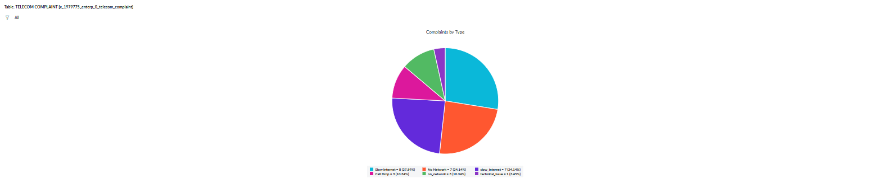
Report — Complaints by Type

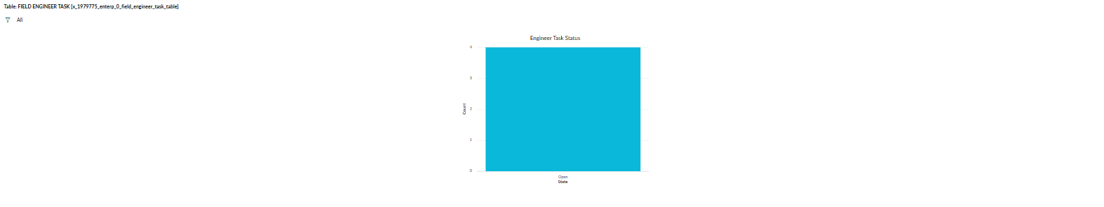
Report — Engineer Task Status

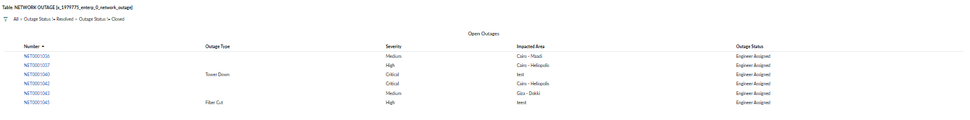
Report — Open Outages

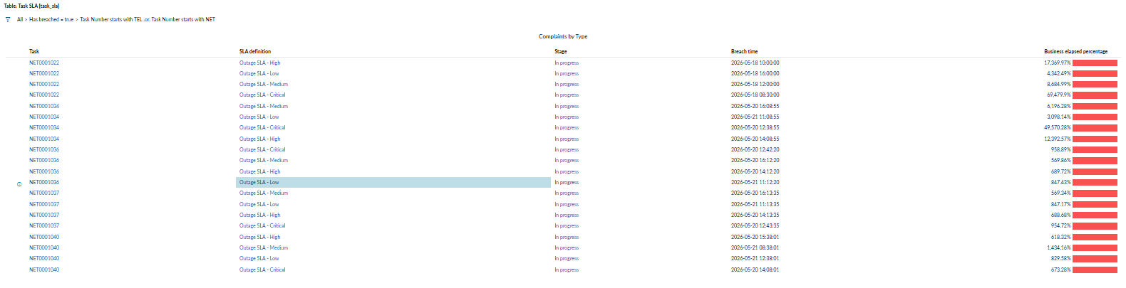
Report — SLA Breach Report

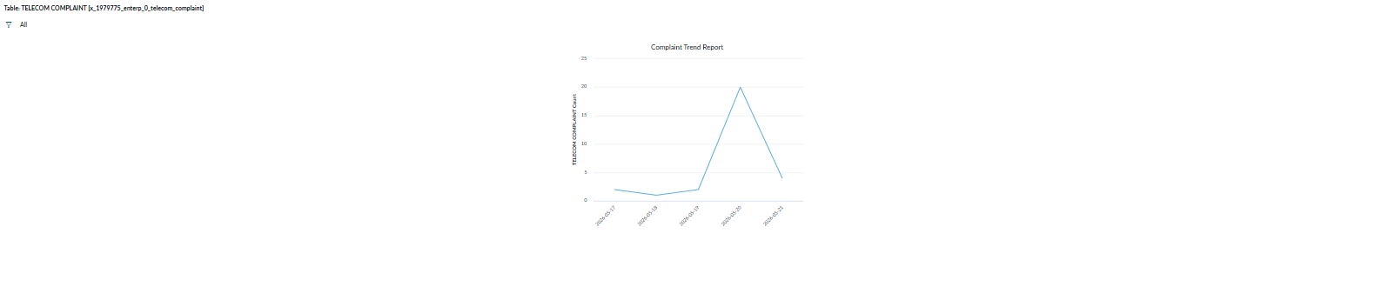
Report — Complaint Trend Report

5.11 Phase 11 — Final Demo & Governance Rules
The complete end-to-end demo flow validated every module in sequence:
- 1. Customer Registration (via Employee Center)
- 2. Portal Login
- 3. Raise Complaint
- 4. Complaint Assignment
- 5. Incident Creation
- 6. Outage Creation
- 7. Engineer Task Creation
- 8. Engineer Resolution
- 9. Outage Closure
- 10. SLA Tracking
- 11. Notification Trigger
- 12. Dashboard Update
The following governance rules were followed throughout the building to keep the implementation clean and maintainable:
Rule | Description
Rule 1 | Use existing Task fields — do not create duplicate fields
Rule 2 | Keep Business Rules simple
Rule 3 | Keep Flow Designer simple — maximum 3–5 actions per flow
Rule 4 | Use Record Producers in the Service Portal
Rule 5 | Avoid advanced/complex scripting
Rule 6 | Test every module separately
Rule 7 | Keep forms simple and clean
Rule 8 | Always test SLA, Notifications, Assignments, Portal submission, and Incident creation before the final demo

Chapter 6: Testing
Testing followed Rule 6 and Rule 8 of the project's governance rules: each module was tested independently first, and the full chain (SLA, Notifications, Assignments, Portal submission, Incident creation) was verified again before the final demo.

6.1 Test Cases
ID | Test Case | Steps | Expected Result
TC-01 | Mobile number validation | Submit Customer form with a mobile number shorter than 10 digits | Client script blocks submission with an error message
TC-02 | Duplicate customer prevention | Create a customer with a mobile number that already exists | BR 2 blocks the insert as a duplicate
TC-03 | Auto portal user creation | Create a new customer profile | A sys_user is created and the customer role assigned (BR 1 — Create Portal User, async)
TC-04 | Auto priority mapping | Set Impact Level to Critical on a new complaint | Priority automatically changes to 1 – Critical (Client Script 2)
TC-05 | Auto complaint assignment | Insert a new complaint record | Complaint is auto-assigned to the Complaint Resolution Team (part of Flow 1 — Complaint Flow)
TC-06 | Auto incident creation | Insert a new complaint record | A linked Incident is created with copied details (part of Flow 1 — Complaint Flow)
TC-07 | Outage-mandatory validation | Set Complaint Type to "No Network" | Related Outage field becomes mandatory (UI Policy 2)
TC-08 | Auto engineer task creation | Insert a new Network Outage record | A Field Engineer Task is auto-created and linked (part of Flow 2 — Outage Flow)
TC-09 | Engineer field required | Submit an Engineer Task with no Engineer selected | Client Script 3 blocks the submission
TC-10 | Auto outage closure | Set Engineer Status to "Work Completed" | The related outage automatically closes (BR 3 — Close Outage)
TC-11 | Complaint SLA timer | Create a Critical complaint and leave it open past 1 hour | SLA breaches and is reflected on the SLA Breaches dashboard widget
TC-12 | Outage SLA timer | Create a Critical outage and leave it open past 30 minutes | SLA breaches and is reflected in the SLA Breach Report
TC-13 | Notification delivery | Trigger each of the six registered events | Corresponding email notification is generated for each event
TC-14 | Customer ACL scoping | Log in as a customer and open the Complaint list | Only that customers’ own complaints are visible (ACL 1 / ACL 2)
TC-15 | Compensation approval flow | Approving a pending Compensation request as Operations Manager | Approval Status updates and customer notification is sent (Flow 3 — Compensation Flow)
TC-16 | Portal complaint submission | Submit the Raise Complaint Record Producer as a customer | New complaint record is created and visible in My Complaints

6.2 Test Scenarios (End-to-End)
In addition to isolated test cases, one continuous end-to-end scenario was executed to confirm that the full chain of automation works together correctly:
- 1. Customer Registration — an employee registers a new customer through the Employee Center; a portal user account is auto-created.
- 2. Complaint — the customer logs in to the portal and raises a "No Network" complaint, which forces the Related Outage field and auto-assigns the complaint.
- 3. Incident — the complaint automatically generates a linked Incident, assigned to the ITSM Support Team.
- 4. Outage — a network engineer logs a related Network Outage, which auto-assigns the Network Operations Team and auto-creates a Field Engineer Task.
- 5. Engineer Task — a field engineer updates their status from Assigned through Traveling, On Site, and Work Completed.
- 6. Resolution — completing the engineer task automatically closes the outage, and the complaint is subsequently marked Resolved / Closed.
- 7. Compensation — the customer requests compensation linked to the resolved complaint; the Operations Manager approves it and the customer is notified.
This scenario confirmed that the SLA timers correctly started and stopped at each stage, that all six notifications fired at the right point in the process, and that the dashboard KPIs (Open Complaints, Active Outages, Engineer Workload) updated correctly as records moved through their lifecycle.

Chapter 7: Results & Discussion

7.1 What Works
- The full automation chain — Complaint → Incident → Outage → Engineer Task → Resolution — executes reliably end-to-end without manual intervention, confirmed by the scenario in Section 6.2.
- SLA timers correctly track resolution time against Priority (complaints) and Severity (outages), and breaches are visible on both the dashboard and the SLA Breach Report.
- Role-based ACLs correctly restrict data visibility per person: customers only see their own complaints, while each internal team only sees the records relevant to their responsibility.
- The Service Portal (Home, Employee Center, Raise Complaint, My Complaints, Outage Status, Compensation Request) delivers a complete customer self-service experience using only low-code Record Producers and out-of-the-box widgets, exactly as required by the project's beginner-friendly build rules.
- Event-driven notifications fire consistently at every key milestone, giving customers and internal teams timely updates without any manual email work.
- The Telecom Operations Dashboard gives operations managers a single view of open complaints, active outages, SLA breaches, engineer workload, and complaint trends.

7.2 Challenges Faced & How They Were Solved
Challenge | Resolution
Deciding how to implement Customer Registration without an open, unauthenticated portal form | Redesigned the flow as an Employee Center: an authorized employee creates the Customer Profile record, keeping onboard under employee control while all other customer interactions (complaints, tracking, compensation) remained on the portal, as explained in Section 1.4.2
Keeping Flow Designer flows simple while still covering multi-step automation (e.g. create record + assign + notify) | Split logic across Business Rules (data-level logic such as auto-assignment and duplicate prevention) and Flow Designer (cross-record orchestration such as creating the linked Incident or Engineer Task), respecting the 3–5 action limit per flow
Making the Related Outage field conditionally mandatory only for "No Network" complaints without confusing agents on other complaint types | Implemented as a scoped UI Policy (UI Policy 2) rather than a hard-coded mandatory field, so the requirement only applies when relevant
Ensuring the automatic outage closure (BR 3 — Close Outage) did not fire prematurely while an engineer was still "On Site" | Scoped the Business Rule condition strictly to Engineer Status = Work Completed, and validated the transition with TC-10
Verifying SLA pause/stop conditions behaved correctly across the Pending and Resolved/Closed states | Tested each state transition individually (TC-11, TC-12) before relying on it inside the end-to-end scenario
Keeping the Service Portal experience simple per Rule 5 while still supporting six distinct customer/employee interactions | Reused Record Producers, the Data Table widget, and the Simple List widget across all six portal pages instead of introducing custom Angular widgets

7.3 Key Learnings
Building this project reinforced a broad set of ServiceNow CSA and development concepts in a realistic, connected scenario rather than in isolation:
- Access Control Lists (ACLs) and how role-based security cascades across related tables
- Table extension of the Task table, and why reusing inherited fields keeps a data model consistent
- Table relationships and reference fields across a multi-table process
- Form design, including sectioned layouts and related lists
- Client Scripts (onSubmit, onChange) and their role in front-end validation and UX
- UI Policies and Data Policies as declarative alternatives to scripted field behavior
- Business Rules (before/after insert and update) for record-level automation
- Script Includes and GlideAjax for reusable, callable server-side logic
- Flow Designer for cross-record, cross-table orchestration
- Events and Notifications as a decoupled way to trigger communication from system activity
- SLA Definitions, including start/pause/stop conditions tied to priority and severity
- Service Portal design using Record Producers and standard widgets
- Reports and Dashboards for turning operational data into KPIs
- The value of following a strict, dependency-aware build order on a real ServiceNow implementation

Chapter 8: Conclusion & Future Work

8.1 Summary
The Enterprise Telecom Operations Management Platform successfully delivers a working, end-to-end ServiceNow application that automates the telecom complaint-to-resolution lifecycle. Starting from customer onboarding (implemented as an Employee Center) through complaint intake, automatic incident creation, network outage tracking, field engineer dispatch, SLA-driven resolution tracking, event-based notifications, customer self-service via the Service Portal, and manager-facing dashboards, the project demonstrates a coherent application of ServiceNow's core ITSM, table, security, automation, portal, and reporting capabilities within a single scoped application.
The only functional deviation from the original project specification is the replacement of an open customer self-registration Record Producer with an employee-facing service for customer onboarding; every other module, table, phase, and governance rule was implemented exactly as specified.

8.2 Future Enhancements
- AI integration: use predictive intelligence or a virtual agent to auto-classify incoming complaints by type and impact level, and to suggest likely root causes for network outages based on historical patterns.
- Real network monitoring integration: connect the Network Outage table to a real telecom monitoring/NMS system via REST so outages are detected and logged automatically rather than manually.
- Mobile field engineer app: extend the Field Engineer Task experience to the ServiceNow mobile app so engineers can update status and resolution notes directly from the field.
- Customer self-registration option: add a controlled, verified self-registration path (e.g. with OTP/email verification) alongside the current Employee Center, for customers who prefer to onboard themselves.
- Advanced analytics: introduce Performance Analytics indicators for longer-term trend analysis of SLA compliance, outage frequency by area, and compensation cost over time.
- Multi-language portal support: extend the Service Portal to support multiple languages for a broader customer base.
- Integration with billing systems: connect the Compensation module to a real billing engine so approved bill credits and refunds are applied automatically.

References & Appendices

References
- ServiceNow Product Documentation — Now Learning / ServiceNow Docs portal (Application Development, ITSM, Flow Designer, Service Portal, Security/ACL, SLA, Notifications, Performance Analytics).
- ServiceNow Certified System Administrator (CSA) exam objectives and study materials.
- ITI (Information Technology Institute) ServiceNow track graduation project brief “Enterprise Telecom Operations Management Platform."
- Internal project specification documents and phase-by-phase build guide used to plan and execute this implementation.

Appendix A — Screenshots Index
The table below lists every screenshot placeholder inserted throughout this document, for quick reference when populating the final version.
# | Section | Screenshot
1 | 4.2.2 | Customer Profile table — dictionary view
2 | 4.2.3 | Service Plan table — dictionary view
3 | 4.2.4 | Telecom Complaint table — dictionary view
4 | 4.2.5 | Network Outage table — dictionary view
5 | 4.2.6 | Field Engineer Task table — dictionary view
6 | 4.2.7 | Compensation table — dictionary view
7 | 4.3 | Table Relationships Diagram / schema map
8 | 4.4.2 | Roles and Groups configuration
9 | 5.1 | Scoped Application, Roles, Groups, Application Menu
10 | 5.2 | Table list with parent table
11 | 5.3 | Form layouts with related lists
12 | 5.4 | ACL list for all five tables
13 | 5.5 | Client Script list and script bodies
14 | 5.6.1 | UI Policy and Data Policy configuration
15 | 5.6.2 | Business Rule list and script bodies
16 | 5.6.3 | Script Include snippets
17 | 5.7 | Flow Designer canvases (Flows 1–6)
18 | 5.8 | SLA Definitions, Events, Notifications
19 | 5.9 | Service Portal pages and Record Producers
20 | 5.10 | Dashboard and standalone reports

Appendix B — Important Code Snippets
Flow Action — Create Incident (part of Flow 1 — Complaint Flow)
Insert the Flow 1 (Complaint Flow) canvas showing the Create Incident action and its field mapping

Business Rule — BR 3: Close Outage (Engineer Task | After Update)


Client Script 2 — Auto Priority (onChange, Complaint)
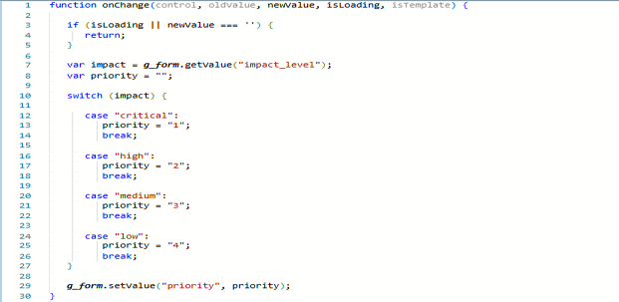
Script Include — CustomerUtils
